Exploring Your Virtual Environment Lab

Ryan Coon

CYB-505

Professor Devin Ogg

July 24, 2024

Screenshots

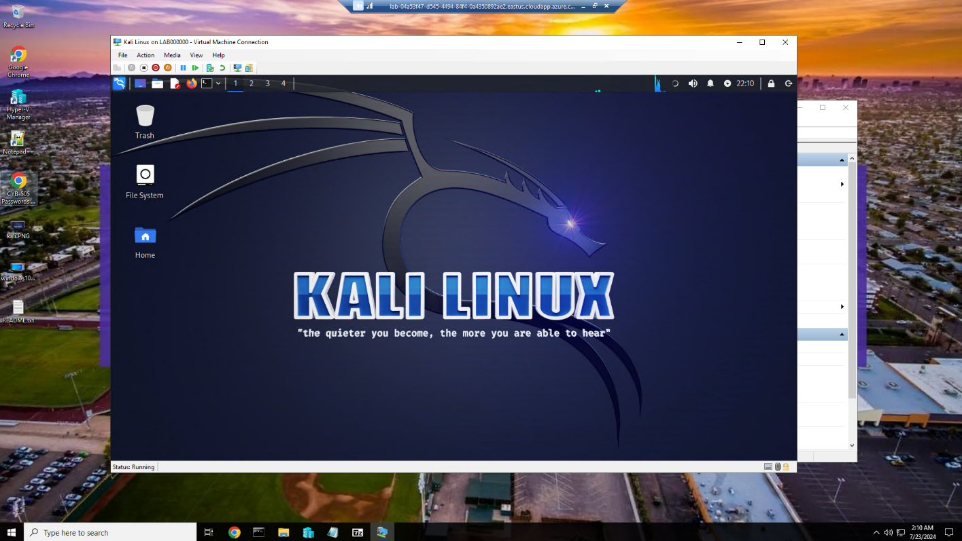

Kali Linux Home screen

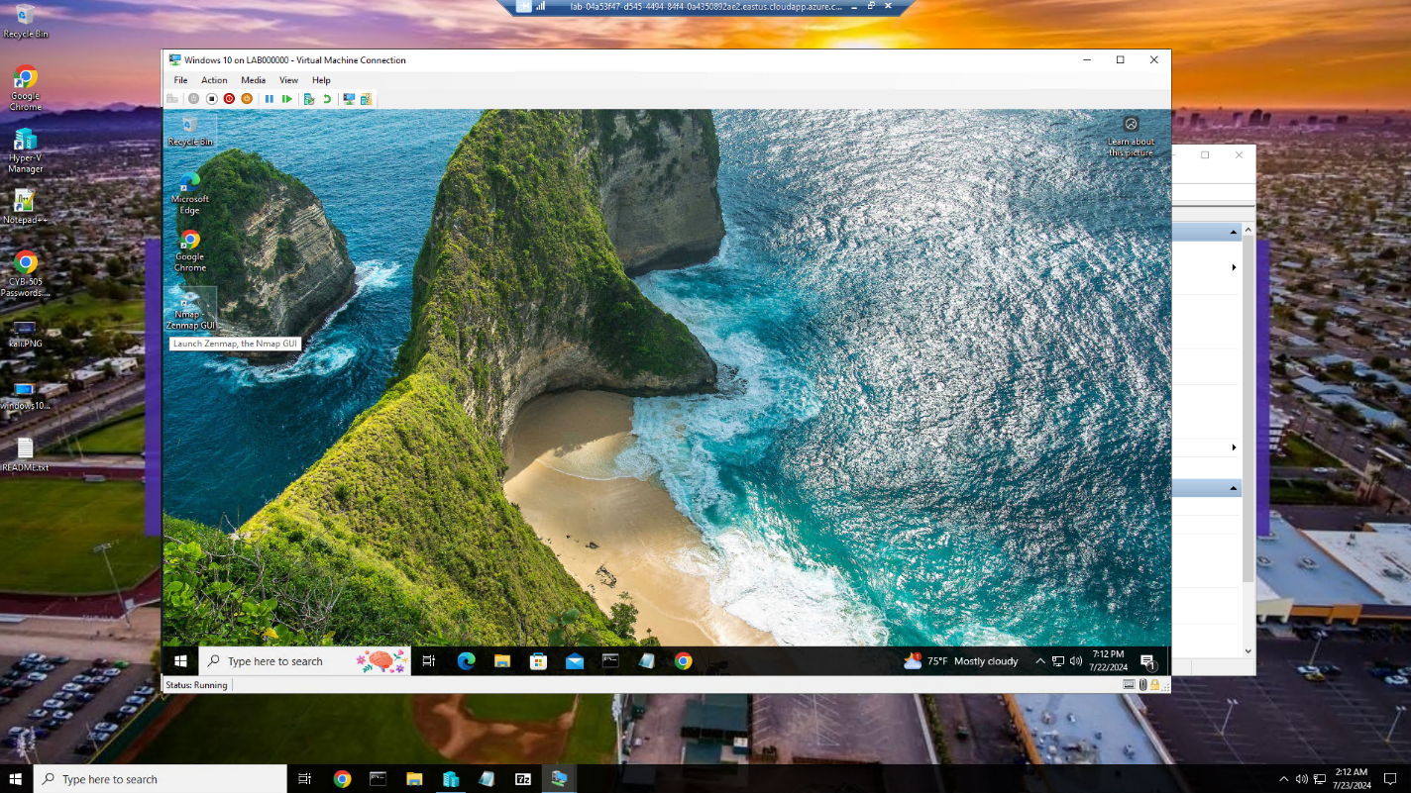

Windows 10 Home Screen

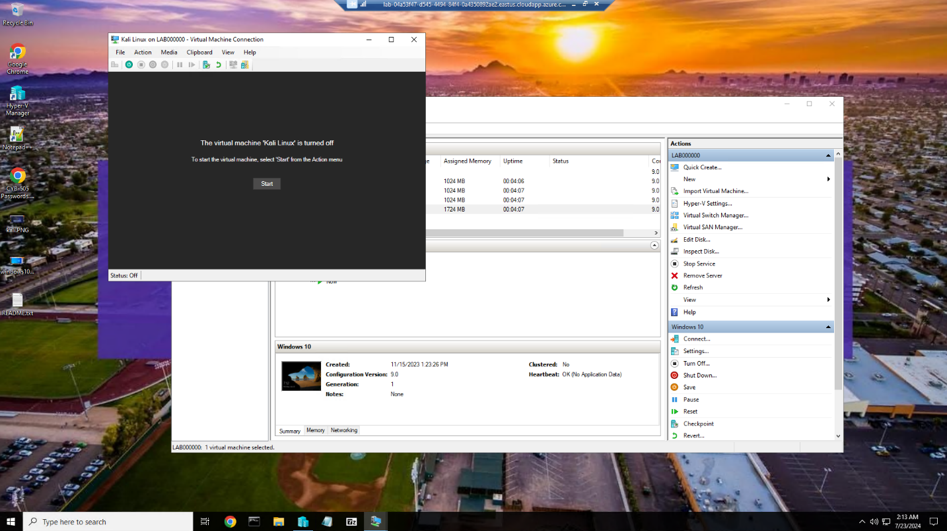

Kali Linux VM shut down

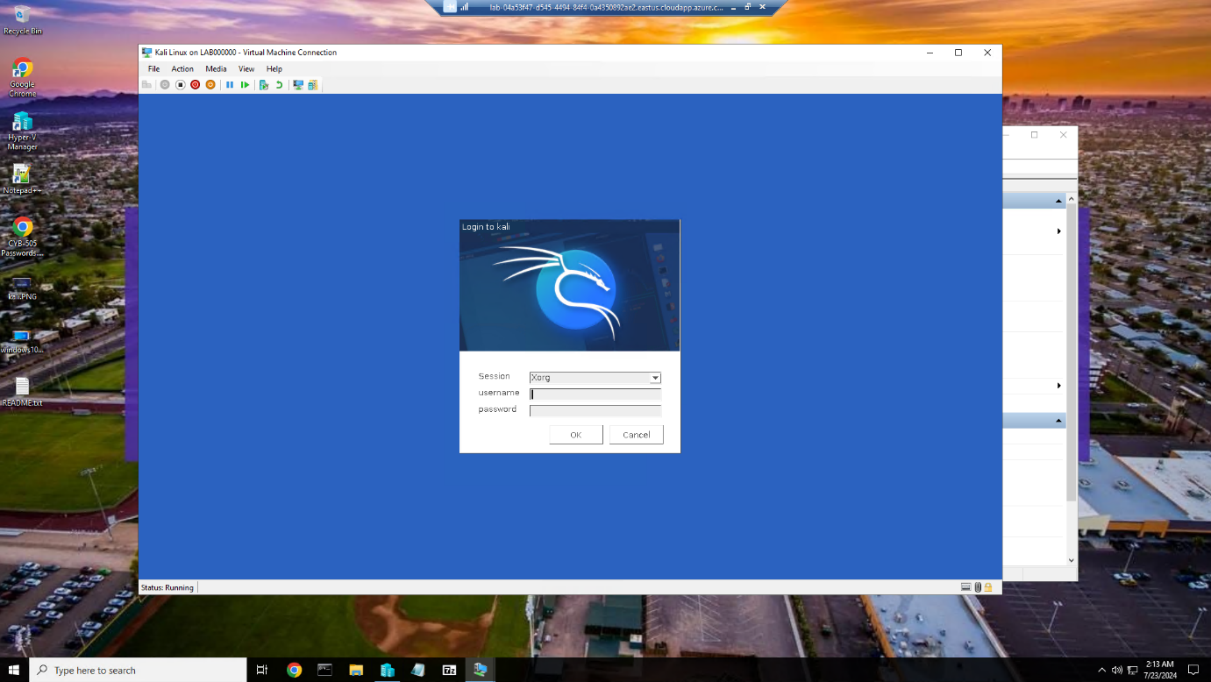

Kali Linux VM Turned back on

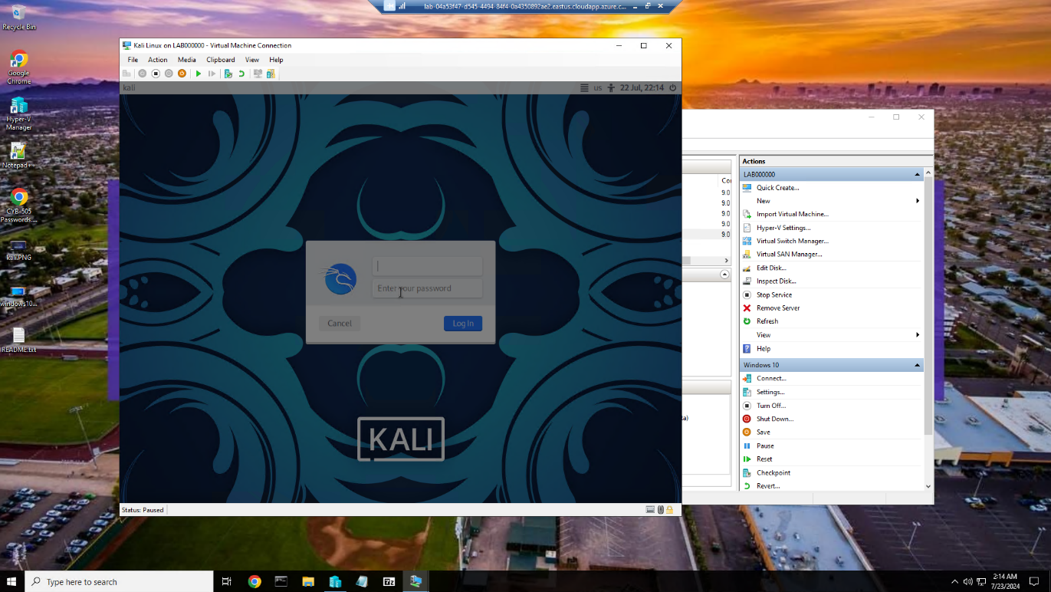

Kali Linux VM paused

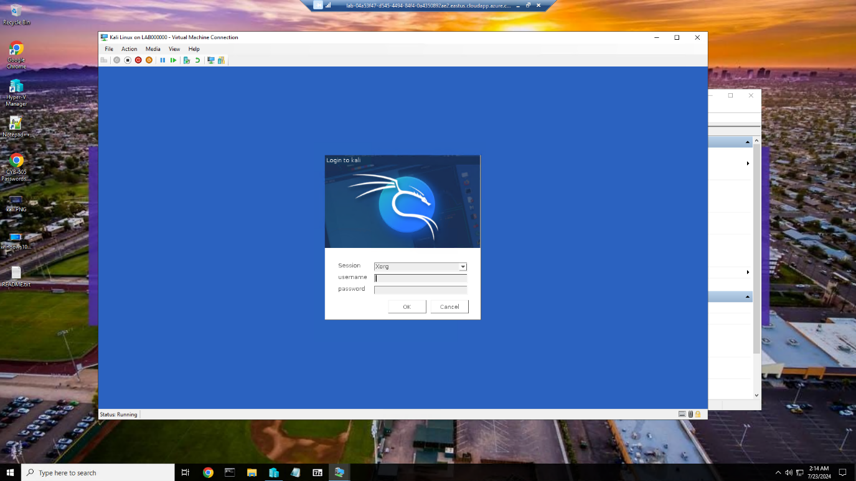

Kali Linux VM unpaused

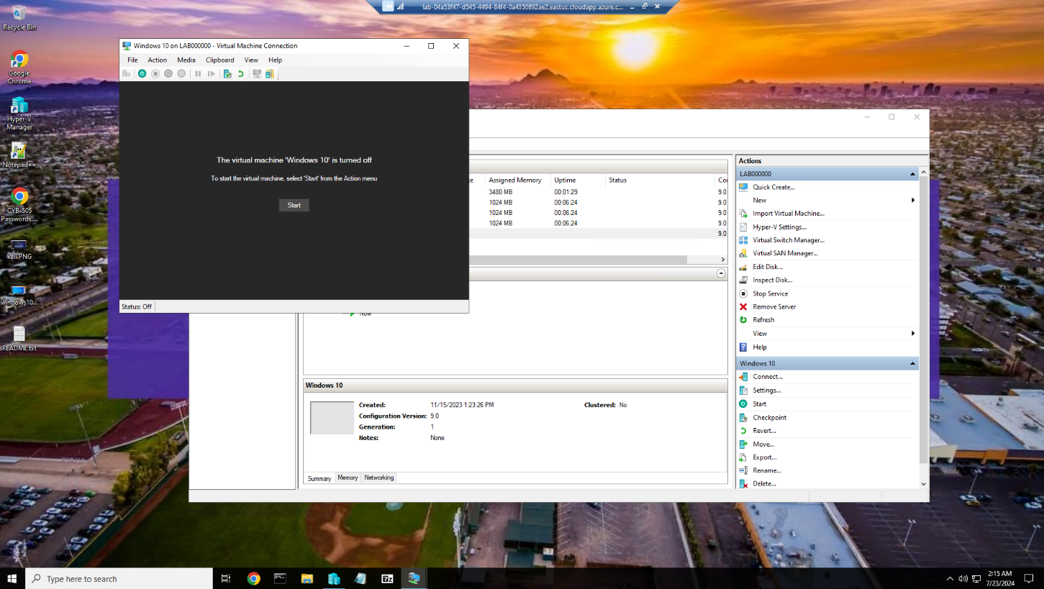

Windows 10 VM Shut down

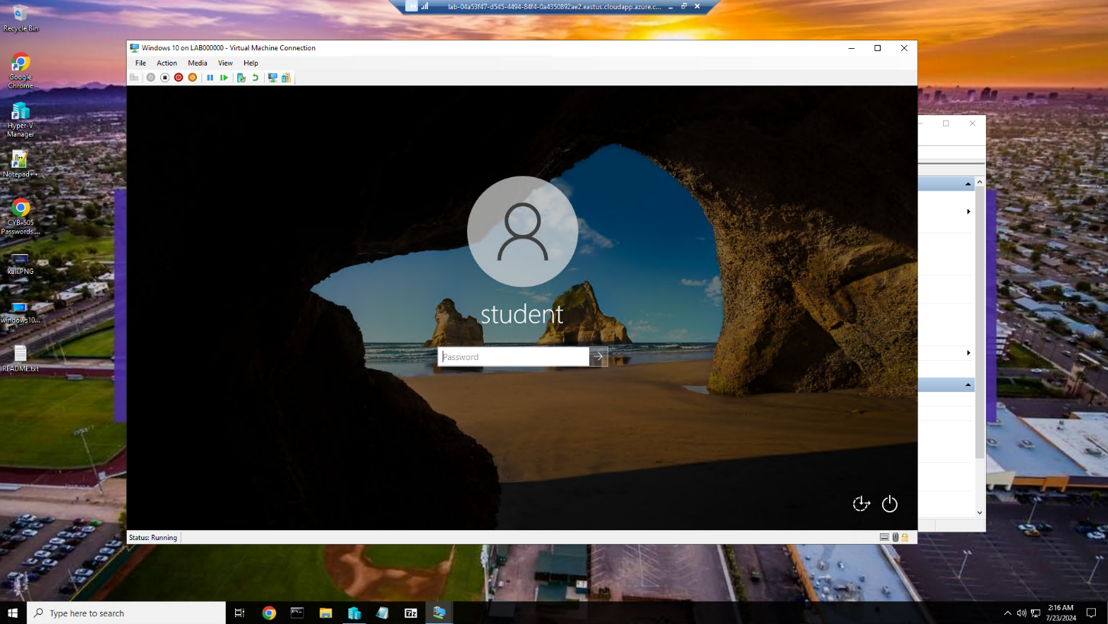

Windows 10 VM turned back on

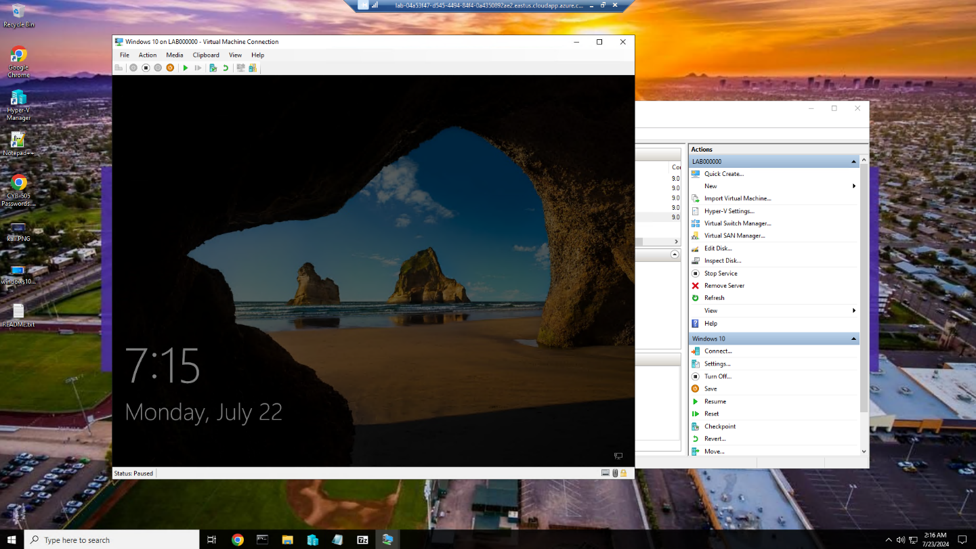

Windows 10 VM paused

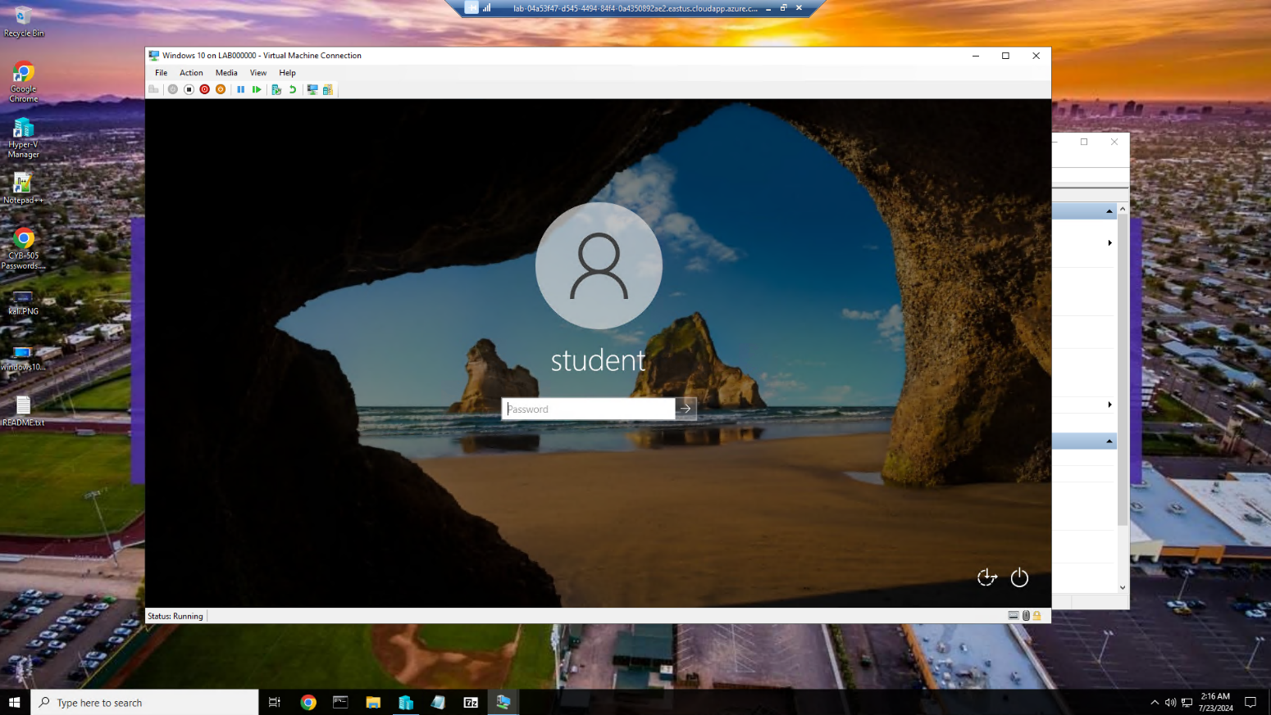

Windows 10 VM unpaused

**Pings:**

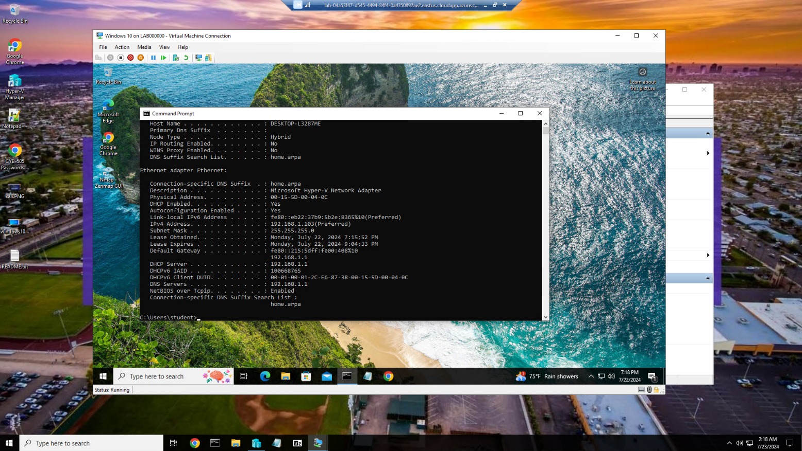

Checked Windows 10 VM ip address and it is 192.168.1.103

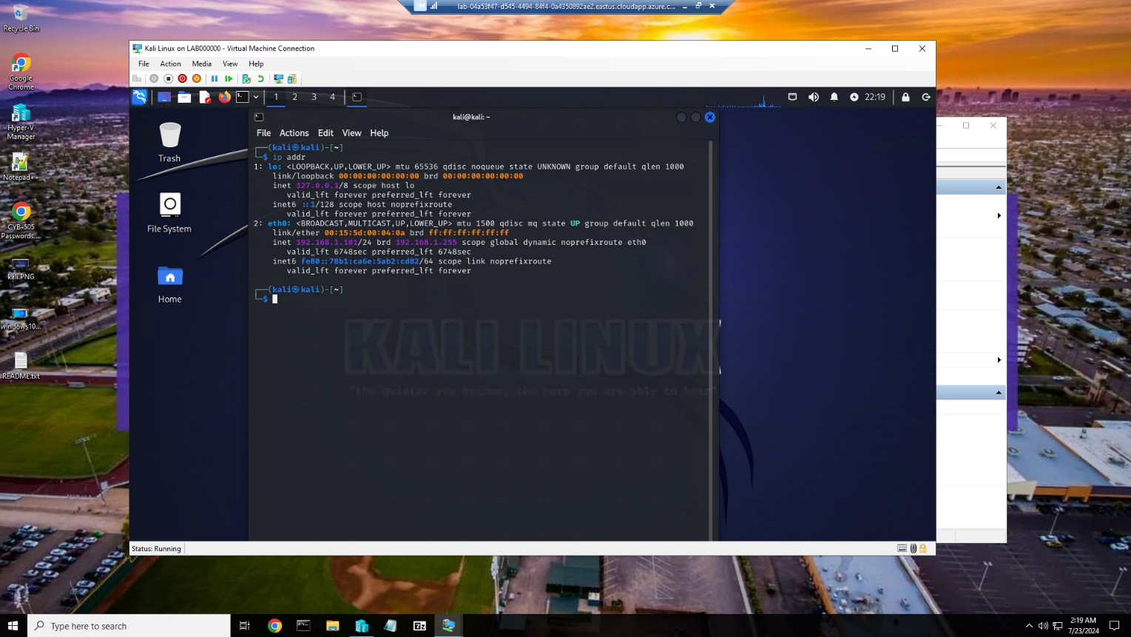

Checked Kali Linux VM ip address and it is 192.168.1.101

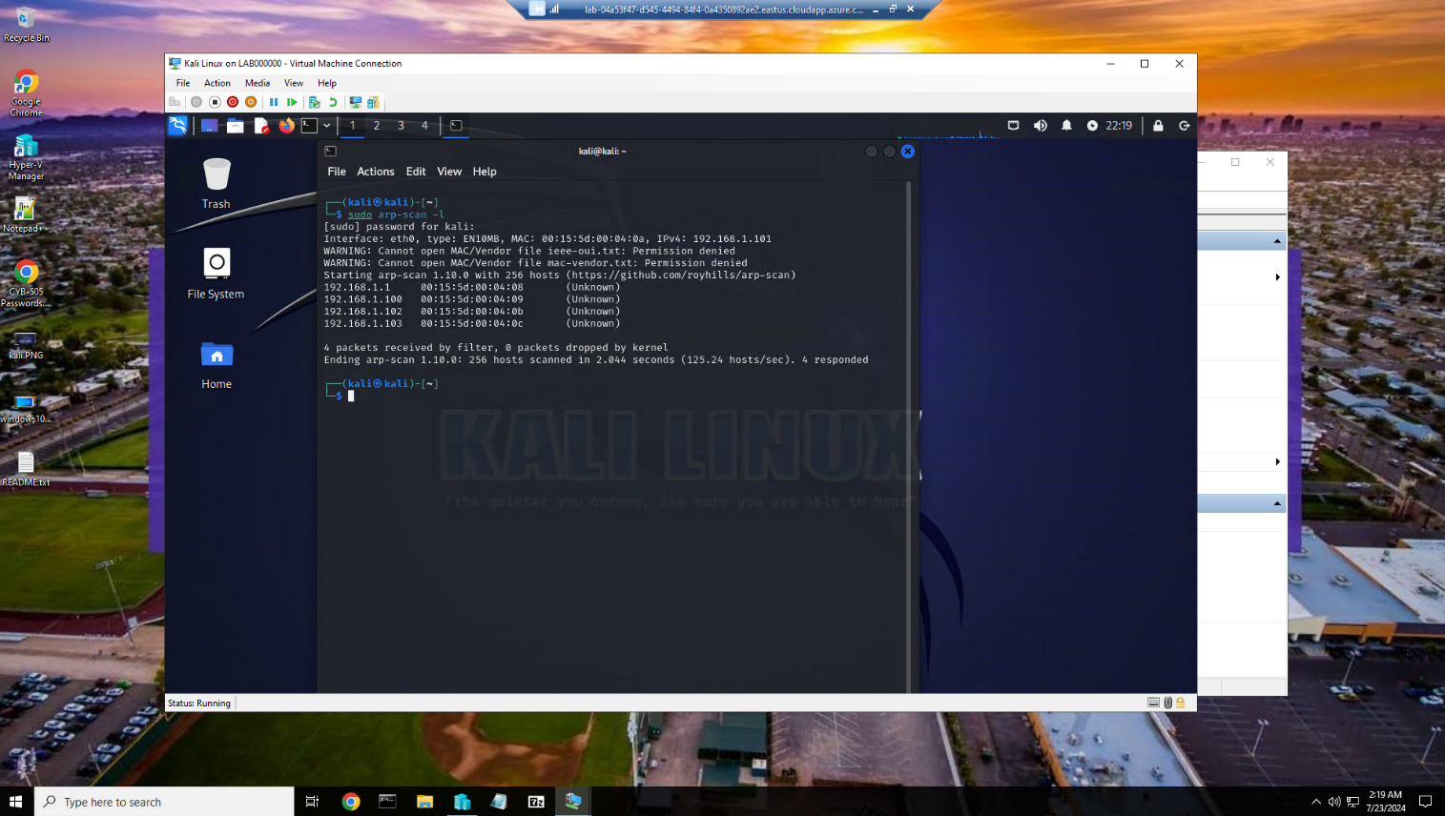

Checked all ip addresses on the network. We know kali is 192.168.1.101, Windows 10 is 192.168.1.103 and pfSense is 192.168.1.1. This mean that Kioptrix 2 and Kioptrix 3 ip addresses are 192.168.1.100 and 198.168.1.102. We will now ping the Windows 10, Kioptrix 2, and Kiptrix 3 VM’s

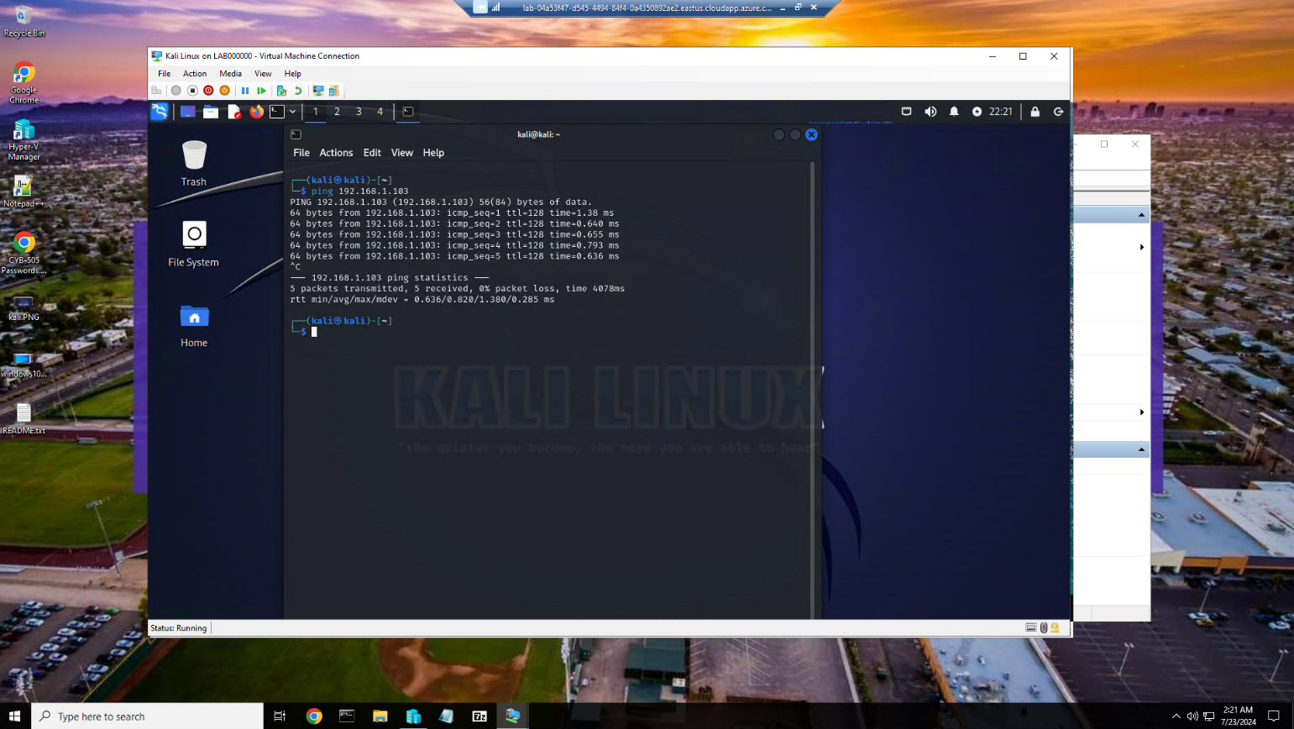

Windows VM ping

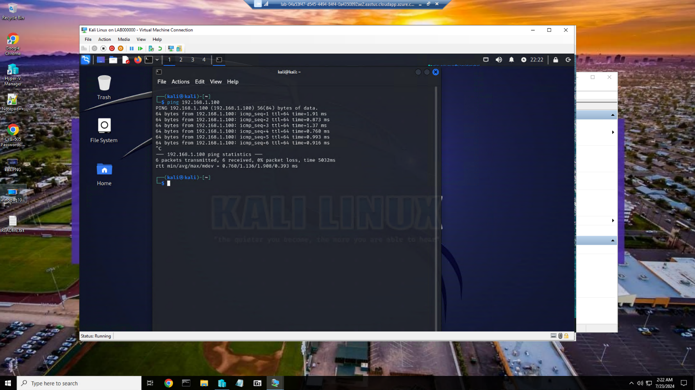

Ping Kioptrix 2

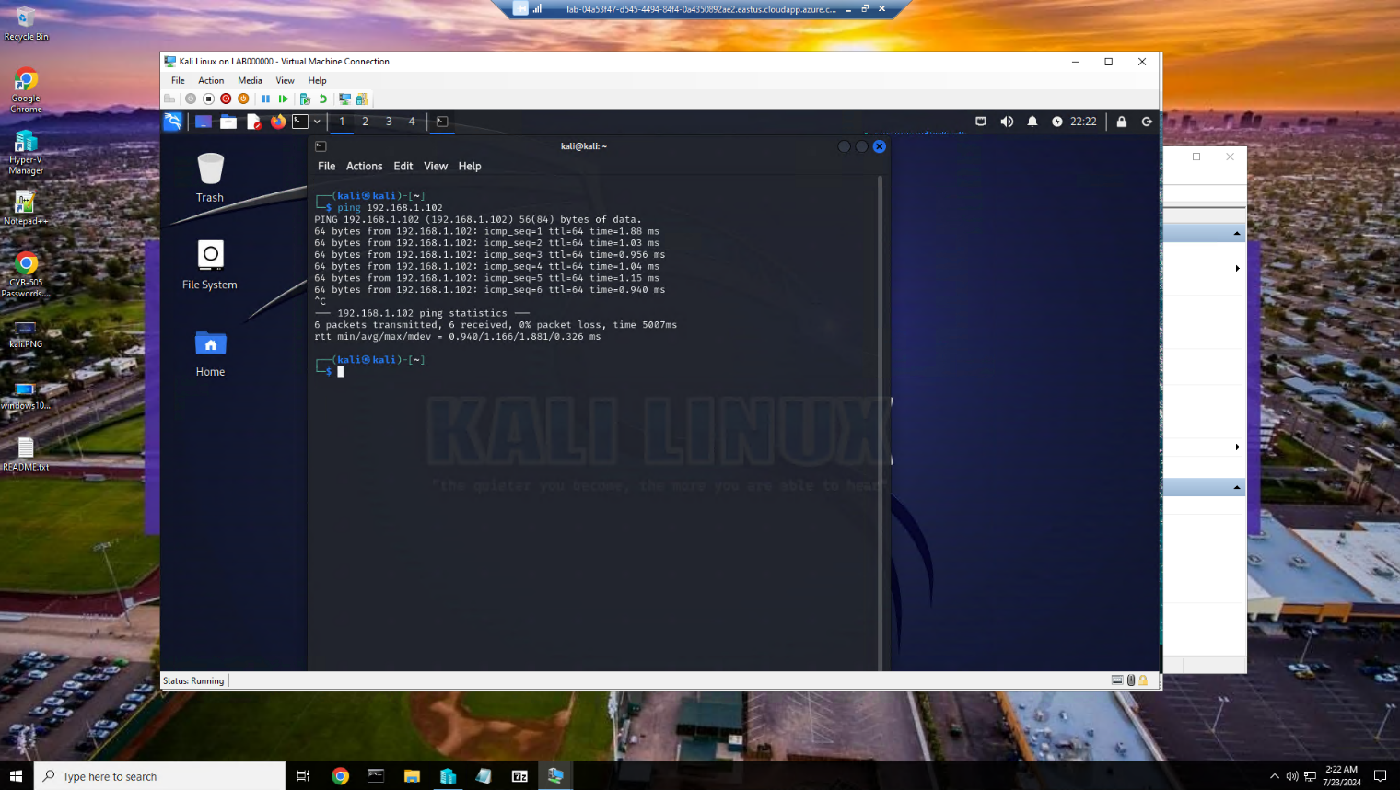

Ping Kioptrix 3

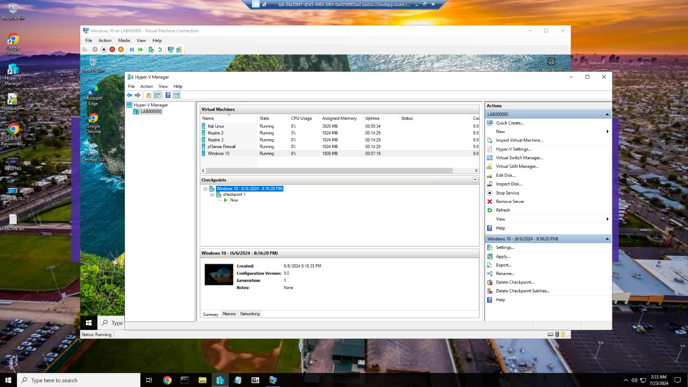

Checkpoint created as “checkpoint 1”

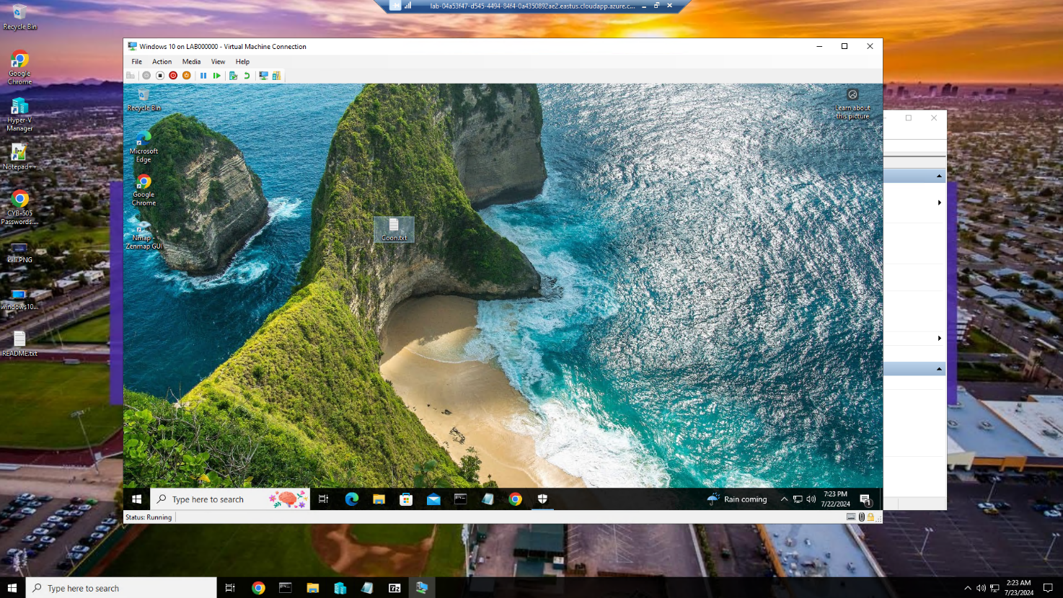

Coon.txt created on desktop

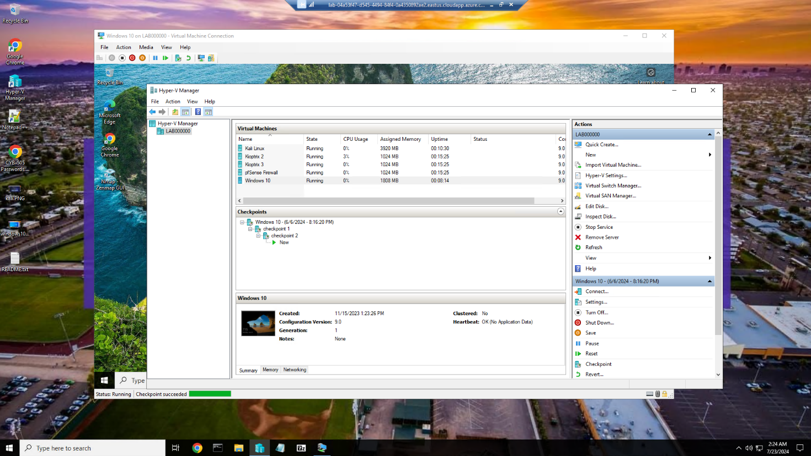

Second checkpoint created named “checkpoint 2”

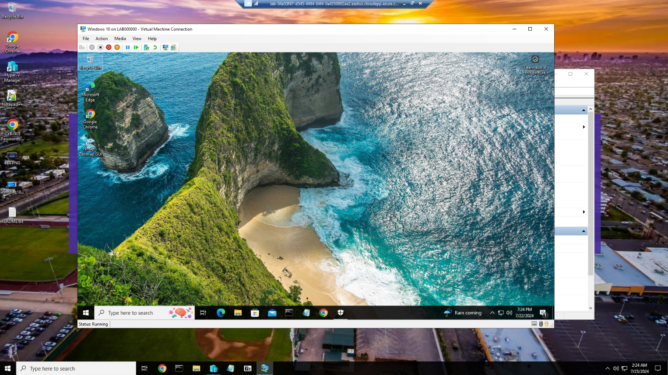

File Coon.txt deleted and recycle bin emptied

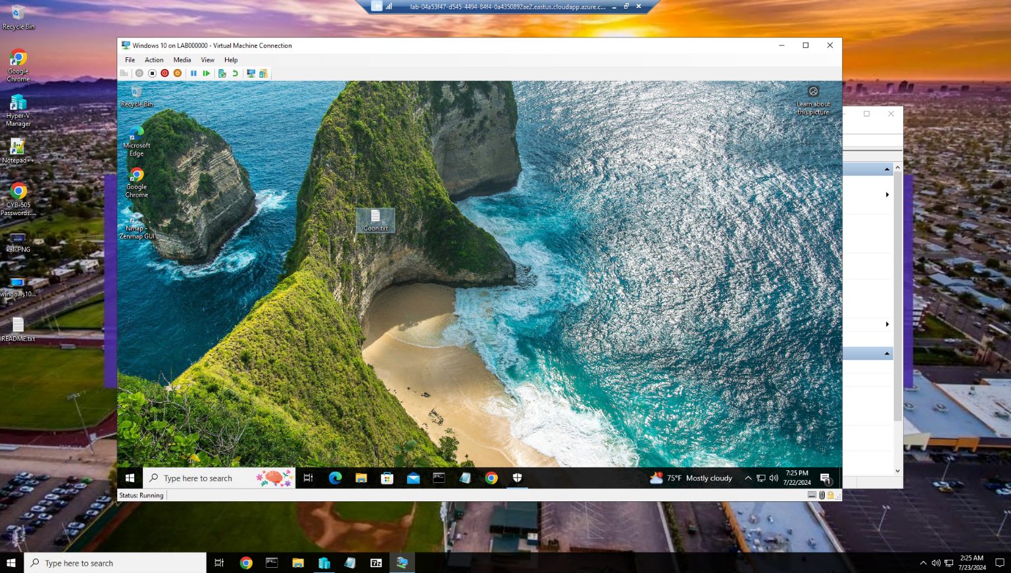

Windows 10 VM successfully reverted to checkpoin2 and Coon.txt is back on the desktop.